

Python Practical’s

Smit Joshi | 20-07-2023

# Practical 1

## Write a program to print numbers from 1 to 50

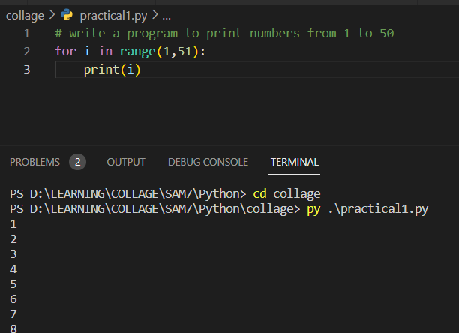

# Practical 2

## Write a program to print all the numbers b/w 11 to 100 which are multiple of 7

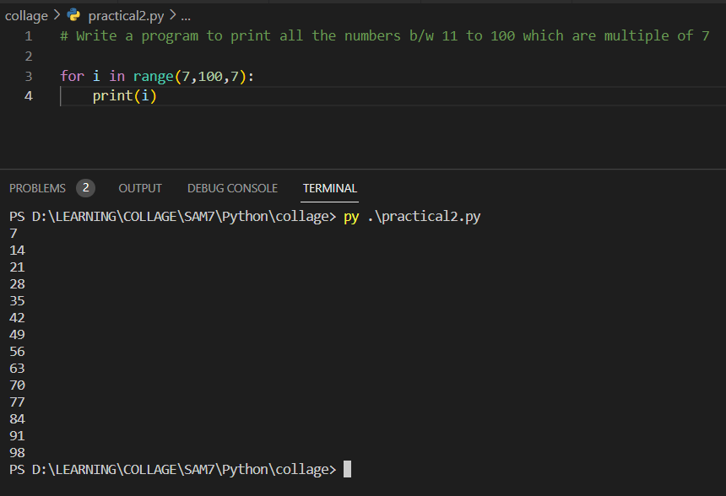

# Practical 3

## Write any Program to print numbers from 75 to 21 in reverse order

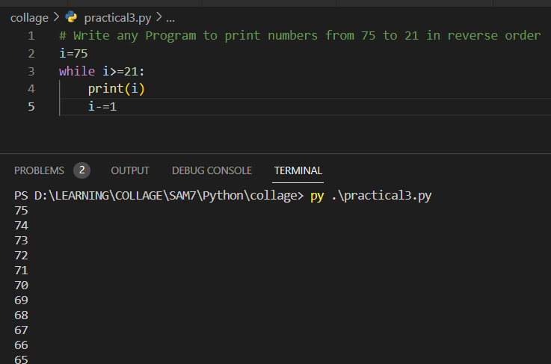

# Practical 4

## # Write a program to get 3 numbers from USER AND find the largest number from it and print the result

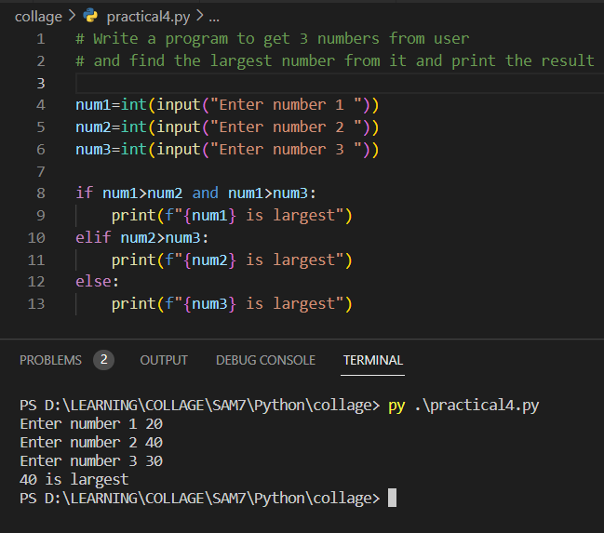

# Practical 5

## # Write a program to take percentage of student as an input and display the grade of student

## if per >=85 Grade A

## per >=75 and <85 Grade B

## per >=65 and <75 Grade C

## per >=55 and <65 Grade D

## per >=40 and <55 grade E

## per <40 Grade F

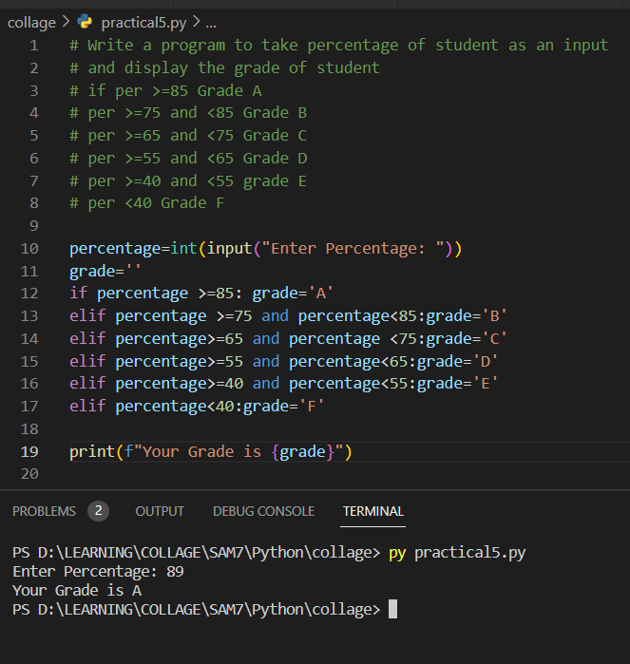

# Practical 6

## # Write a program to take input from user and find wheather the number is even or odd

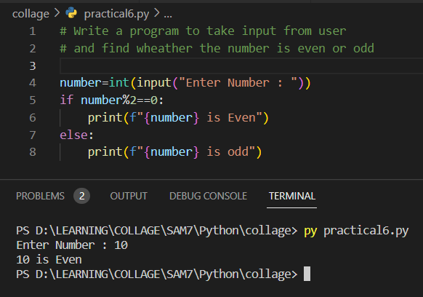

# Practical 7

## #Write a program to take 7 numbers from user and calculate the sum of THOSE 7 NUMBERS & DISPLAY RESULTS

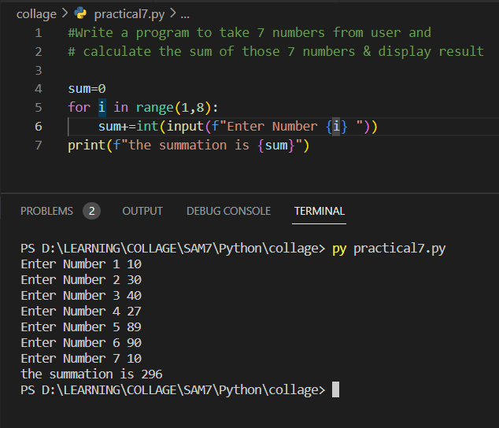

# Practical 8

## # Write a program to calculate sum of all the numbers b/w 71 to 80

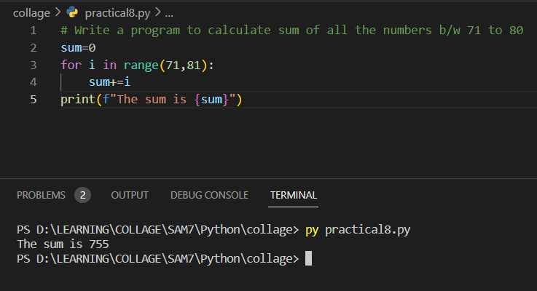

# Practical 9

## # Write a program to find the product of all the numbers b/w 21 to 30

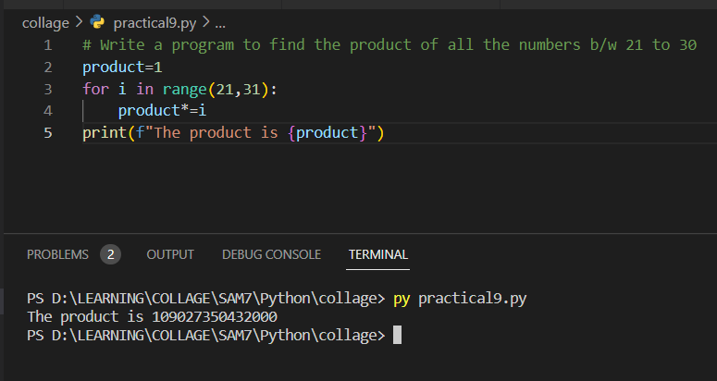

# Practical 10

## #Write a program to find the given number is prime or not

